Database Design Specification
Titanic Teeth Clinic Belfast

Introduction and Scope
Currently Titanic Teeth, a local Belfast dental clinic, is suffering from an inconvenient database and booking system. The system is often storing duplicate data and is not working as efficiently as required. With current systems being incredibly slow it makes work difficult and often leads to patient frustration. Ideally the system to be developed should work efficiently, prevent mass duplications of data and as such make the information easily understood by the user.

Aim
The aim of this project is to deliver a database and booking system for dental appointments, the recording of stock information and patient information.

Objectives
Specific: I will build a database for Titanic Teeth clinic to improve overall efficiently
Measurable: I will work on the database for 1 hour each day and the goal is to have it complete in 2-3 weeks
Achievable: I will finish building the tables within one week
Relevant: I want to help the people at Titanic Teeth be able to work more efficiently
Timely: I will have the database completed before December 9th

Definitions
- Patient – A single person that has made or will be making an appointment with Titanic Teeth
- Staff – A person that is employed by Titanic Teeth
- Treatment – Is when a patient is administered a procedure by a staff member
- Appointment – Between a staff member and a patient which takes place at a specific date and time
- Treatment Type – The key that defines the difference between treatments
- Private Price – The cost for a treatment if a patient is registered under private healthcare instead of the NHS
- Treatment Availability – This shows if a treatment is available for NHS patients or only for private patients

Functional Requirements
MoSCow Table Must have (M)/ Should have (S)/ Could have (C)/Won’t Have (W)
Item | Description | Priority
1 | Store new patient details | M
2 | Store treatment details | M
3 | Store new staff details | M
4 | Store appointment details | M
5 | Allow for editing of patient details | S
6 | Allow deletion of patient details | S
7 | View patient details | S
8 | Allow for a report to be generated | C
9 | Editing of appointment details | S
10 | Deletion of appointments | S
11 | View appointments for each staff member | C
12 | Allow for treatment information to be edited | S
13 | Allow for treatment information to be deleted | S
14 | Text based search bar for each area | C
15 | Search via date | C
16 | Disallowing of a staff or patient to have overlapping appointments | M
17 | Only trained staff will be available to be assigned to take care of an appointment | M
18 | A GUI with interactive bookings | W
19 | Basic patient information displayed when assigning appointment | C
20 | Help messages displayed upon user request | C

System Constraints
- The project must be completed within 7 weeks.
- The database must be accessible from several different users simultaneously.
- The database must be able to store patient information.
- The database must be able to store staff information.
- The database must be able to store treatment information.
- The database must be able to store appointment information.

Planning - Project Schedule
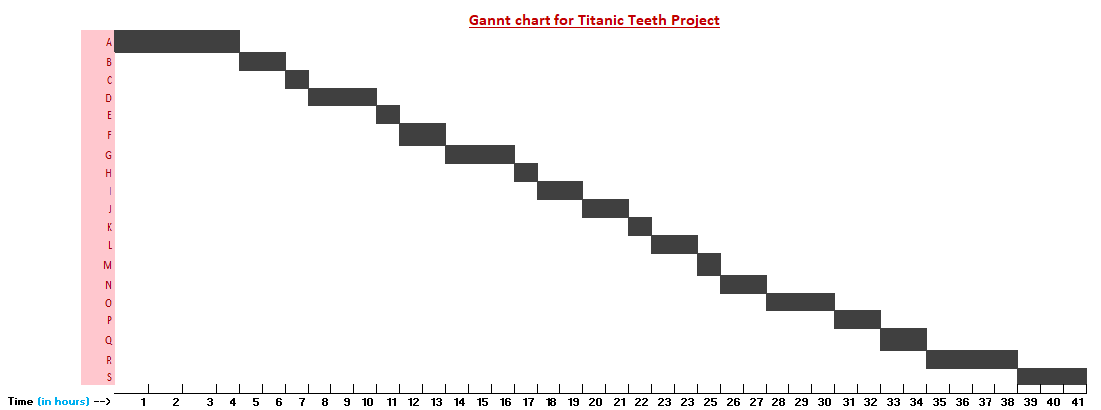
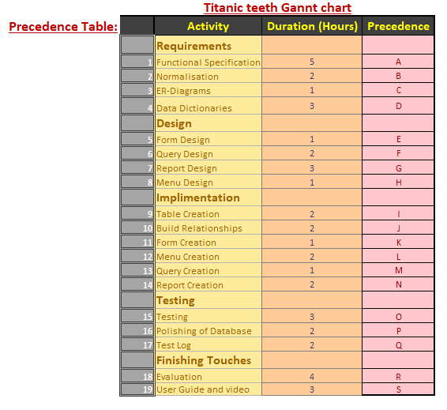

Backend Design

Data Analysis
The source of data came from Titanic Teeth. They presented tables of information relating to their storage of data. This allowed for the building of the normalisation and the understanding of what was required from the database. They presented information relating to customers, staff, treatments and appointments. As such it was decided to take each entity from these presented tables and design the database based of them.

Data Dictionary Entries
Database File | titanicTeeth.accdb | Table Name | tblPatient | (Composite)Key Field | PatientID
Related to:
Table Name | Foreign Key | Table Name | Foreign Key
tblAppointment | PatientID | tblTreatmentRecord | PatientID

General table description:
This table holds information about the patients for Titanic Teeth to access

Field Name | Key | Data Type | Format | Length | Input Mask/Validation Rule/Validation Text | Default Value | Description | Typical Data
PatientID | P | AutoNumber |  | 5 |  |  | Uniquely identifies a patient | 1
Forename |  | Short Text |  | 30 |  |  | Patient’s legal Forename | Martha
Surname |  | Short Text |  | 30 |  |  | Patient’s legal Surname | Johnston
Address |  | Short Text |  | 60 |  |  | Patient’s home address | 88 Saintfield Road
City/Town |  | Short Text |  | 25 |  |  | City or town the address is in | Belfast
County |  | Short Text |  | 20 |  |  | The county the address is in | Down
Postcode |  | Short Text |  | 8 | >LL09\ 0LL |  | Postcode associated with the address | BT1 7HS
Mobile |  | Short Text |  | 11 | >00000000000 |  | Patient’s personal phone number to allow for contact | 07837654872
Email |  | Short Text |  | 40 |  |  | Patient’s email to allow for contact | marthajohnston@gmail.com
CareOption |  | Short Text | Value List | 7 |  | NHS | To determine if the patient is through private or NHS care | NHS
Notes |  | Short Text |  | 255 |  |  | In case anything important about a patient needs noted | Scared of needles

Database File | titanicTeeth.accdb | Table Name | tblStaff | (Composite)Key Field | StaffID
Related to:
Table Name | Foreign Key | Table Name | Foreign Key
tblAppointment | StaffID | tblTreatmentRecord | StaffID

General table description:
This table holds information about the staff member of Titanic Teeth

Field Name | Key | Data Type | Format | Length | Input Mask/Validation Rule/Validation Text | Default Value | Description | Typical Data
StaffID | P | AutoNumber |  | Auto |  |  | Uniquely identifies a staff member | 1
Forename |  | Short Text |  | 30 |  |  | Staff’s legal forename | Jordan
Surname |  | Short Text |  | 30 |  |  | Staff’s legal surname | Smyth
Role |  | Short Text |  | 20 |  |  | Staff’s role in the clinic | Dentist
Address1 |  | Short Text |  | 60 |  |  | Staff’s home address | 23 Cregagh Rd
City/Town |  | Short Text |  | 25 |  |  | The City or Town the address is in | Belfast
Postcode |  | Short Text |  | 8 | >LL09\ 0LL |  | Postcode associated with the address | BT6 9KS
Mobile |  | Short Text |  | 11 | >00000000000 |  | Staff’s work or personal number for contact | 07290384765
Email |  | Short Text |  | 40 |  |  | Staff’s work email to allow for contact | jordansmyth@yahoo.com

Database File | titanicTeeth.accdb | Table Name | tblAppointment | (Composite)Key Field | StaffID, PatientID, DateTimeBooked
Related to:
Table Name | Foreign Key | Table Name | Foreign Key
tblStaff | StaffID | tblPatient | PatientID
tblTreatmentRecord | DateTimeBooked

General table description:
This table holds information about the time and date of an appointment for a patient

Field Name | Key | Data Type | Format | Length | Input Mask/Validation Rule/Validation Text | Default Value | Description | Typical Data
StaffID | P F | Number |  | Auto |  |  | Uniquely identifies a staff member | 1
PatientID | P F | Number |  | Auto |  |  | Uniquely identifies a patient | 1
DateTimeBooked | P | Date/Time |  | Auto |  |  | Shows the date and time appointment is booked for | 25/11/22 – 15:00:00
Payment |  | Short Text |  | 15 |  |  | Describes how payment will be decided | On delivery

Database File | titanicTeeth.accdb | Table Name | tblTreatment | (Composite)Key Field | TreatmentCode
Related to:
Table Name | Foreign Key | Table Name | Foreign Key
tblTreatmentRecord | TreatmentCode

General table description:
This table holds information about the treatments offered by Titanic Teeth

Field Name | Key | Data Type | Format | Length | Input Mask/Validation Rule/Validation Text | Default Value | Description | Typical Data
TreatmentCode | P | AutoNumber |  | Auto |  |  | Uniquely identifies the treatment | 1
Type |  | Short Text |  | 30 |  |  | Name of the treatment | Filling
Availability |  | Short Text | Value List | 7 |  | Both | If it is available through private, NHS or both | Private
PrivatePrice |  | Number | Currency | Auto |  |  | Price if private | £30.00

Database File | titanicTeeth.accdb | Table Name | tblTreatmenRecord | (Composite)Key Field | StaffID, PatientID, TreatmentCode
Related to:
Table Name | Foreign Key | Table Name | Foreign Key
tblAppointment | DateTimeBooked | tblStaff | StaffID
tblPatient | PatientID | tblTreatment | TreatmentCode

General table description:
This table holds information about the Items relating to a particular Invoice

Field Name | Key | Data Type | Format | Length | Input Mask/Validation Rule/Validation Text | Default Value | Description | Typical Data
StaffID | P F | Number |  | 5 |  |  | Uniquely identifies a staff member | 1
PatientID | P F | Number |  | 5 |  |  | Uniquely identifies a patient | 1
DateTimeBooked | P F | Short Text |  | 15 |  |  | Shows the date and time appointment is booked for | 25/11/22 – 15:00:00
TreatmentCode | P F | Number |  | 5 |  |  | Uniquely identifies a treatment | 1
Quantity |  | Number | Integer | 10 |  |  | Number of treatments of a particular type | 4

Legend: | Key | P | (Primary) | F | (Foreign)

Physical Entity Relationship Diagram
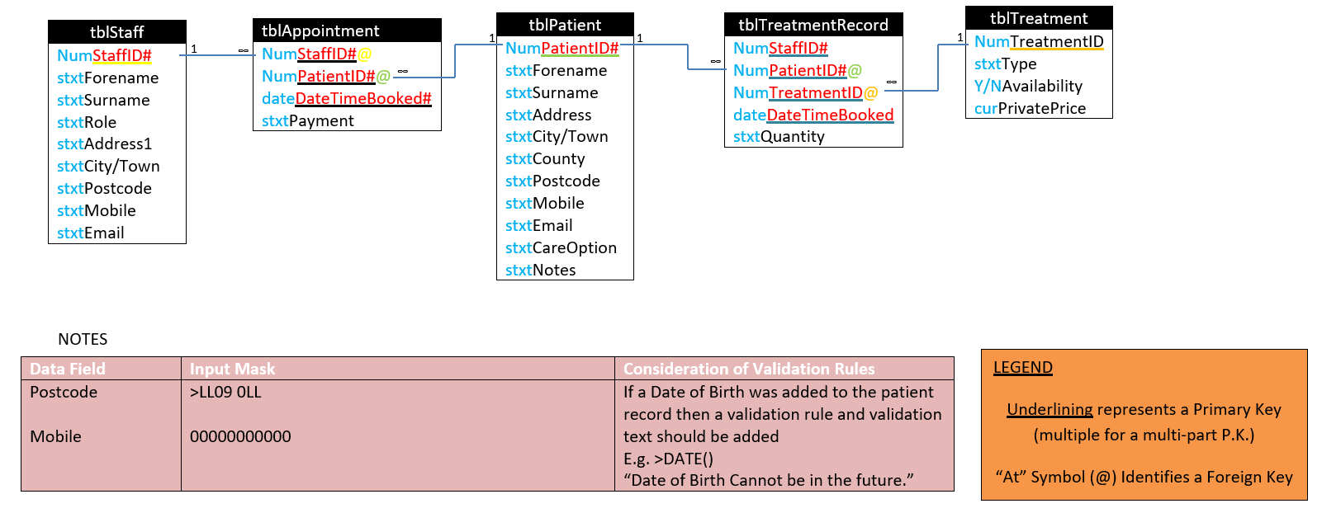

Frontend Design

Project: titanicTeeth.accdb – Menu Form

Date: 02/12/22
Screen 1 of 12  Links to and from screens: frmPatient, frmStaff,  frmTreatment,  frmAppointment,  frmTreatmentRecord,  frmReports |  | Screen description:  This form will be used to navigate to the other forms in the database

Functionality/interactivity:
Red – Six buttons linking to the other forms. Each noted with the name of their respective form
Blue – Logo/Company Name
Background:  Mint Green  Colour scheme:  Red/ Blue  Text attributes:  “Titanic Teeth” Logo |  | Main Task:  To allow for the user to navigate to other forms seamlessly.

Project: titanicTeeth.accdb – Patient Form

Date: 02/12/22
Screen 2 of 12  Links from screens:  frmMainMenu  Links to screens:  frmMainMenu |  | Screen description:  This form will be used to add patient details to the database.

Functionality/interactivity:
Blue – Text to show patient attribute
Orange – Text boxes to allow staff to enter patient information. Will have validation to stop empty values or incorrect values being entered in certain areas, such as letter in a phone number.
Red – Buttons to add patient details and take the user back to the menu form
Yellow – Text Label of Titanic Teeth
Purple – Picture Box Logo
Green – Subform to show patient history
Background:  Mint Green  Colour scheme:  Green/Orange/Blue/Red  Text attributes:  beside text boxes |  | Main Task:  To allow for the input of patient data into the database

Project: titanicTeeth.accdb – Staff Form

Date: 02/12/22
Screen 3 of 12  Links from screens:  frmMainMenu  Links to screens:  frmMainMenu |  | Screen description:  This form will be used to add staff details to the database

Functionality/interactivity:
Blue – Text to show staff attribute
Orange – Text boxes to allow staff to enter patient information. Will have validation to stop empty values or incorrect values being entered in certain areas, such as letter in a phone number. The “Role” field will contain a list box for the user to select from
Red – Buttons to add patient details and take the user back to the menu form
Yellow – Text Label of Titanic Teeth
Purple – Picture Box Logo
Background:  Mint Green  Colour scheme:  Green/Orange/Blue/Red  Text attributes:  beside text boxes |  | Main Task:  To allow for the input of staff data into the database

Project: titanicTeeth.accdb – Treatment Form

Date: 02/12/22
Screen 4 of 12  Links from screens:  frmMainMenu  Links to screens:  frmMainMenu |  | Screen description:  This form will be used to add treatment details to the database

Functionality/interactivity:
Blue – Text label to show treatment attribute
Orange – Text boxes to allow staff to enter treatment information. Will have validation to stop empty values or incorrect values being entered in certain areas, such as letter in a price. The “Availability” field will contain a list box for the user to select from
Red – Buttons to add treatment details and take the user back to the menu form
Yellow – Text Label of Titanic Teeth
Purple – Picture Box Logo
Background:  Mint Green  Colour scheme:  Green/Orange/Blue/Red  Text attributes:  beside text boxes |  | Main Task:  To allow for the input of treatment data into the database

Project: titanicTeeth.accdb – Appointment Form

Date: 02/12/22
Screen 5 of 12  Links from screens:  frmMainMenu  Links to screens:  frmMainMenu |  | Screen description:  This form will be used to add appointment details to the database

Functionality/interactivity:
Blue – Text label to show different IDs
Orange – Text boxes to allow staff to select appropriate patient and staff for an appointment. Will have validation to stop empty values or incorrect values being entered in certain areas. The ID fields will have list boxes to allow for selection
Red – Buttons to add appointment details and take the user back to the menu form
Yellow – Text Label of Titanic Teeth
Purple – Picture Box Logo
Background:  Mint Green  Colour scheme:  Green/Orange/Blue/Red  Text attributes:  beside text boxes |  | Main Task:  To allow for the booking of appointments with particular staff members

Project: titanicTeeth.accdb – Treatment Record Form

Date: 02/12/22
Screen 6 of 12  Links from screens:  frmMainMenu  Links to screens:  frmMainMenu |  | Screen description:  This form will be used to add treatment details to appointments.

Functionality/interactivity:
Blue – Text label to show available treatment details and appointment details
Orange –List boxes will be used to select a certain appointment. Will have validation to stop empty values or incorrect values being entered in certain areas.
Red – Buttons to appointment details and take the user back to the menu form
Yellow – Text Label of Titanic Teeth
Purple – Picture Box Logo
Background:  Mint Green  Colour scheme:  Green/Orange/Blue/Red  Text attributes:  beside text boxes |  | Main Task:  To allow for the input of treatment data into appointments

Project: titanicTeeth.accdb – Patient Edit Form

Date: 02/12/22
Screen 7 of 12  Links from screens:  frmMainMenu  Links to screens:  frmMainMenu |  | Screen description:  This form will be used to edit patient details on the database.

Functionality/interactivity:
Blue – Text to show patient attributes
Orange – Text boxes to allow staff to edit patient information. Will have validation to stop empty values or incorrect values being entered in certain areas, such as letter in a phone number. To the bottom right selection for patient to edit via list box.
Red – Buttons to save patient details and take the user back to the menu form
Yellow – Text Label of Titanic Teeth
Purple – Picture Box Logo
Green – Subform to show patient history
Background:  Mint Green  Colour scheme:  Green/Orange/Blue/Red  Text attributes:  beside text boxes |  | Main Task:  To allow for the editing of patient data

Project: titanicTeeth.accdb – Staff Edit Form

Date: 02/12/22
Screen 8 of 12  Links from screens:  frmMainMenu  Links to screens:  frmMainMenu |  | Screen description:  This form will be used to add staff details to the database

Functionality/interactivity:
Blue – Text to show staff attribute
Orange – Text boxes to allow staff to edit patient information. Will have validation to stop empty values or incorrect values being entered in certain areas, such as letter in a phone number. A list box to select patient information to edit
Red – Buttons to edit staff details and take the user back to the menu form
Yellow – Text Label of Titanic Teeth
Purple – Picture Box Logo
Background:  Mint Green  Colour scheme:  Green/Orange/Blue/Red  Text attributes:  beside text boxes |  | Main Task:  To allow for the editing of staff data in the database

Project: titanicTeeth.accdb – Appointment Edit Form

Date: 02/12/22
Screen 9 of 12  Links from screens:  frmMainMenu  Links to screens:  frmMainMenu |  | Screen description:  This form will be used to edit appointment details in the database

Functionality/interactivity:
Blue – Text label to show different IDs
Orange – Text boxes to allow staff to select appropriate patient and staff for an appointment. Will have validation to stop empty values or incorrect values being entered in certain areas. The ID fields will have list boxes to allow for selection
Red – Buttons to edit appointment details and take the user back to the menu form
Yellow – Text Label of Titanic Teeth
Purple – Picture Box Logo
Background:  Mint Green  Colour scheme:  Green/Orange/Blue/Red  Text attributes:  beside text boxes |  | Main Task:  To allow for the booking of appointments with particular staff members

Project: titanicTeeth.accdb – Treatment Record Form

Date: 02/12/22
Screen 10 of 12  Links from screens:  frmMainMenu  Links to screens:  frmMainMenu |  | Screen description:  This form will be used to edit treatment details in appointments.

Functionality/interactivity:
Blue – Text label to show available treatment details and appointment details
Orange –List boxes will be used to select a certain appointment. Will have validation to stop empty values or incorrect values being entered in certain areas.
Red – Buttons to edit treatment record details and take the user back to the menu form
Yellow – Text Label of Titanic Teeth
Purple – Picture Box Logo
Background:  Mint Green  Colour scheme:  Green/Orange/Blue/Red  Text attributes:  beside text boxes |  | Main Task:  To allow for the editing of treatment data in appointments

Project: titanicTeeth.accdb – Treatment Record Report

Date: 02/12/22
Screen 11 of 12  Links from screens:  frmMainMenu  Links to screens:  frmMainMenu |  | Screen description:  This form will be used to display treatment details for each appointment made by a patient

Functionality/interactivity:
Blue – Text label to show patient
Orange –Text Label to show treatment name and quantity
Red – Back button
Yellow – Text Label of Titanic Teeth
Purple – Picture Box Logo
Background:  Mint Green  Colour scheme:  Green/Orange/Blue/Red  Text attributes:  beside text boxes |  | Main Task:  To display treatment record details

Project: titanicTeeth.accdb – Treatment Earnings Report

Date: 02/12/22
Screen 12 of 12  Links from screens:  frmMainMenu  Links to screens:  frmMainMenu |  | Screen description:  This form will be used to display treatment details for each appointment made by a patient

Functionality/interactivity:
Blue – Text label to show treatment name
Orange –Text Label to show treatment quantity and total price
Green – Text label to show grand total
Red – Back button
Yellow – Text Label of Titanic Teeth
Purple – Picture Box Logo
Background:  Mint Green  Colour scheme:  Green/Orange/Blue/Red  Text attributes:  beside text boxes |  | Main Task:  To display treatment earnings details

Test(ing) Plan
Database being tested: | titanicTeeth | Intended date of testing: | 09/12/2022

Test Number | Testing For | Table Name | Field Name | Expect to see\find | Purpose of Test
1 | Add Staff Menu Button |  |  | Opening of Add Staff form | To ensure navigation works
2 | Add Patient Menu Button |  |  | Opening of Add Patient form | To ensure navigation works
3 | Add Treatment Menu Button |  |  | Opening of Add Treatment form | To ensure navigation works
4 | Add Appointment Menu Button |  |  | Opening of Add Appointment form | To ensure navigation works
5 | Edit Staff Menu Button |  |  | Opening of Edit Staff form | To ensure navigation works
6 | Edit Patient Menu Button |  |  | Opening of Edit Patient form | To ensure navigation works
7 | Edit Treatment Menu Button |  |  | Opening of Edit Treatment form | To ensure navigation works
8 | Edit Appointment Menu Button |  |  | Opening of Edit Appointment form | To ensure navigation works
9 | Treatment Record Report Menu Button |  |  | Opening of Treatment Record Report | To ensure navigation works
10 | Treatment Earnings Report Menu Button |  |  | Opening of Treatment Earnings Report | To ensure navigation works
11 | Add Patient Button | tblPatient |  | Appropriate record added | To ensure saving information works
12 | Add Staff Button | tblStaff |  | Appropriate record added | To ensure saving information works
13 | Add Treatment Button | tblTreatment |  | Appropriate record added | To ensure saving information works
14 | Add Appointment Button | tblAppointment,  tblTreatmentRecord |  | Appropriate record added | To ensure saving information works
15 | Edit Patient Button | tblPatient |  | Appropriate record edited | To ensure editing information works
16 | Edit Staff Button | tblStaff |  | Appropriate record edited | To ensure editing information works
17 | Edit Treatment Button | tblTreatment |  | Appropriate record edited | To ensure editing information works
18 | Edit Appointment Button | tblAppointment,  tblTreatmentRecord |  | Appropriate record edited | To ensure editing information works
19 | Null value entries | All |  | Null values rejected unless it is notes on patient form | To ensure no data errors occur
20 | Delete patient button | tblPatient |  | Appropriate record deleted | To ensure deletion occurs
21 | Delete staff button | tblStaff |  | Appropriate record deleted | To ensure deletion occurs
22 | Delete treatment button | tblTreatment |  | Appropriate record deleted | To ensure deletion occurs
23 | Delete appointment button | tblAppointment,  tblTreatmentRecord |  | Appropriate record deleted | To ensure deletion occurs
24 | Delete linked data records | tblAppointment,  tblTreatmentRecord,  tblPatient,  tblStaff,  tblTreatment |  | Error message warns user and stops deletion of linked records | To ensure no data errors occur
25 | Letter entry in mobile field | tblStaff, tblPatient | Mobile | User will not be able to enter letter | To ensure it is a phone number
26 | Valid postcode entry | TblStaff, tblPatient | Postcode | User will only be able to enter valid postcode | To ensure it is a valid postcode
27 | Check combo box | tblStaff, tblPatient | StaffID, PatientID, Forename, Surname, Postcode etc…(All fields) | User will observe available data for either staff or patient | To ensure accessibility for user
28 | Back button |  |  | Return to menu form | To ensure the database can be navigated

Test(ing) Evidence
Database being tested: | titanicTeeth | Tested By: | Ethan Russell 50057876

Test Number | Description | Test Data | Expected Result | Actual Result | Pass/Fail | Action Taken
1 | Add Staff Menu Button |  | Opening of Add Staff form | Opening of Add Staff form | Pass
2 | Add Patient Menu Button |  | Opening of Add Patient form | Opening of Add Patient form | Pass
3 | Add Treatment Menu Button |  | Opening of Add Treatment form | Opening of Add Treatment form | Pass
4 | Add Appointment Menu Button |  | Opening of Add Appointment form | Opening of Add Appointment form | Pass
5 | Edit Staff Menu Button |  | Opening of Edit Staff form | Opening of Edit Staff form | Pass
6 | Edit Patient Menu Button |  | Opening of Edit Patient form | Opening of Edit Patient form | Pass
7 | Edit Treatment Menu Button |  | Opening of Edit Treatment form | Opening of Edit Treatment form | Pass
8 | Edit Appointment Menu Button |  | Opening of Edit Appointment form | Opening of Edit Appointment form | Pass
9 | Treatment Record Report Menu Button |  | Opening of Treatment Record Report | Opening of Treatment Record Report | Pass
10 | Treatment Earnings Report Menu Button |  | Opening of Treatment Earnings Report | Opening of Treatment Earnings Report | Pass
11 | Add Patient Button  tblPatient | 28,  Ethan,  Russell,  26 Kilmakee Park,  Belfast,  Antrim,  BT5 7QY,  07572856738,  ethan.rus@gmail.com,  NHS,  Penicillin Allergy | Appropriate record added | Appropriate record added | Pass
12 | Add Staff Button  tblStaff | 5, Jeremy, Blair, Admin, 56 Enshore Lane, Belfast, BT9 6BB,  07894124155, jeremyblair@titanicteeth.co.uk | Appropriate record added | Appropriate record added | Pass
13 | Add Treatment Button  tblTreatment | 8, Root Canal, Both, £40.00 | Appropriate record added | Appropriate record added | Pass
14 | Add Appointment Button  tblAppointment  tblTreatmentRecord | 5, 5, 17/12/2022, On Arrival | Appropriate record added | Appropriate record added | Pass
15 | Edit Patient Button  tblPatient | Antrim | Appropriate record edited | Appropriate record edited | Pass
16 | Edit Staff Button  tblStaff | Dentist | Appropriate record edited | Appropriate record edited | Pass
17 | Edit Treatment Button  tblTreatment | £40.99 | Appropriate record edited | Appropriate record edited | Pass
18 | Edit Appointment Button  tblAppointment  tblTreatmentRecord | Invoice | Appropriate record edited | Appropriate record edited | Pass
19 | Null value entries  All Tables/Fields | “ ” | Null values rejected unless it is notes on patient form | Null values rejected unless it is notes on patient form | Pass
20 | Delete patient button |  | Appropriate record deleted | Appropriate record deleted | Pass
21 | Delete staff button |  | Appropriate record deleted | Appropriate record deleted | Pass
22 | Delete treatment button |  | Appropriate record deleted | Appropriate record deleted | Pass
23 | Delete appointment button |  | Appropriate record deleted | Appropriate record deleted | Pass
24 | Delete linked data records |  | Error message warns user and stops deletion of linked records | Error message warns user and stops deletion of linked records | Pass
25 | Letter entry in mobile field  tblStaff, tblPatient  Mobile field | “07fg4365641” | User will not be able to enter letter | User will not be able to enter letter | Pass
26 | Valid postcode entry  TblStaff, tblPatient  Postcode field | “BTT 888” | User will only be able to enter valid postcode | User will only be able to enter valid postcode | Pass
27 | Check combo box |  | User will observe available data for either staff or patient | User will observe available data for either staff or patient | Pass
28 | Back button |  | Return to menu form | Return to menu form | Pass

Evaluation
Introduction
- The original problem I had set out to solve was to create a more efficient system to minimise the duplication of data, increase productivity and allow for easy use via the user.
- The task originally appeared achievable. However, there were many issues encountered along the way. Many of these issues were not foreseen beforehand. As such, the difficulty of the taste was arguably misleading. This is not a massive issue as it offered a good challenge but as stated previously the difficulty was not overwhelming.
- My approach to the planning of this project would be considered fairly standard. As displayed above I started with surveying the prospects and beginning with a concise purpose, scope and aim to give me guidance and stay on track to achieve what was desired of the clients. Next was simply defining objective, definitions and functional requirements. All of which allowed me to ensure I was hitting every mark as to what was desired from the client. This helped me throughout the project by encouraging me and enabling me to stay productive and efficient. The use of a Moscow table also ensured that I would not focus on anything that may be considered relatively unproductive. After I began to focus on the gantt chart which was possibly the biggest contributor to efficiency. It allowed me to stay on track and easily monitor how much time I should be spending on each part of the project and ensure I was staying within a reasonable time limit.
- I mentioned my client multiple times already. This client was Titanic Teeth. An up-and-coming dental surgery which was in dire need of a database to allow them to work efficiently and ensure patient satisfaction. They originally had envisioned a database that would easily allow them to add patients, new staff members, new treatments and new appointments. As well as a way to edit all of the previously mentioned fields. They also wanted a way to easily view their earning and appointment. All of which was provided.
- I appreciate that I put effort into working on the planning at the beginning of the project and it did keep me mostly on track. However, I must be honest in saying I was slightly naïve with some prospects of the project in the sense that some things were definitely more difficult than expected and took longer than expected.
The Systems Investigation
- Originally the clients at Titanic Teeth had presented me with tables of data that most definitely needed reworked as they were very susceptible to data repetition.
- Most of the determining of data inputs, processes and function applied to data came from consulting with Titanic Teeth as to what they desired and a bit of common sense as to what a dental surgery may require or as to what is being stored.
- The biggest issue was making sense of the data provided. Whilst it was very useful to see exactly what was being stored and what needed to be stored it was still messy and required much consideration from both myself and Titanic Teeth.

Data Analysis
- I approached the data analysis with what the clients at Titanic Teeth need and desire. As such I produced normalisation tables and diagrams to show the optimal storage of data. With the information provided I believe the chosen configuration was the most efficient and allowed for the easiest usage of the clients.
- The inclusion of quantity of treatments for each patient relating to the appointments proved to be a bit of a difficulty as it caused the inclusion of a fifth “TreatmentRecord” table. This, I believe, was the best approach as it kept the integrity of provided data whilst keeping the repetition of stored data to a minimum.
- Without modelling the data it would have been significantly more difficult moving forward with the project as I most definitely would have encountered many issues if I chose to store the data as it was provided. As such I am thankful that I did this beforehand as it stopped the repetition of data.
Design
- Not many problems were encountered when creating the data dictionaries as the previous data modelling significantly helped with simplifying this process. I had to ensure that fields such as Postcode or Mobile would be stored correctly and as such the appropriate input masks were included to ensure a lack of errors.
- When it came to reports I had to take into account what was desired and needed of the clients at Titanic Teeth. As such I included queries to feed the appropriate information into the reports. Two calculations were required for this; the treatment subtotals and the total. This was done relatively easily using SQL.
- The design overall changed from the storyboard stage as better methods were found during development for the inputting of data. However, the storyboards made for a very necessary inspiration for the early stages of design and gave me a direction to follow at the start.

ACCEPTANCE TESTING
- The clients at Titanic Teeth, as previously stated, expected a database that would allow them to work efficiently and ensure patient satisfaction. They originally had wanted a database that would easily allow them to add patients, new staff members, new treatments and new appointments. As well as a way to edit all of the previously mentioned fields. They also wanted a way to easily view their earning and appointment.
- The clients were very pleased with the finished product as it met the requirements they had originally envisioned. However they did mention that improvements to some of the subforms could be made and possibly the inclusion of more robust reports. Overall the client was quite pleased
- The system was able to meet all of the requirements on the MoSCow table apart from some of the search functionality and help messages upon request.
Database Evaluation
- The ER Diagram is reflected perfectly in the finished product. It was followed aptly
- The data dictionaries were followed accordingly and allowed for ample tables to store data
- The storyboards were followed to an extent. Primarily followed in the intentions of each form. Overall, the design and colour-scheme changed drastically.
- The finished system meets the original requirements quite well, almost all were achieved.
- Overall, I would say I am quite happy with how the final product turned out. However I do believe that there were definitely improvements that could be made if more time was available. However, given the window of time provided I believe the job was done well.
REFLECTIVE APPRECIATION
- I believe I have gained a deeper understanding of data storage and usage of Microsoft Access, which is quite valuable.
- Planning is an essential part to all projects. It provides incredible amounts of support throughout the project and I believe and project could not be finished to a high quality without it.
- Following a system development methodology allows for routine which is very important with keeping on track in a project.
- Without data analysis this project could have been a disaster in that many hours would have been wasted in trying different configurations of data relationships and tables.
- Without aesthetic inspiration I do believe I would have taken longer with the project as it allowed me to efficiently design forms and give me more time to focus on functionality.
- The usage of subforms in Microsoft Access was something I learnt throughout this project and it has made me wary of how to not use them incorrectly.
- I will be able to apply my knowledge gained of Microsoft Access to future projects. As well as the usage and importance of things like data dictionaries or gantt charts.
- With the gift of foresight, I would have spent less time on ideas that never came to fruition. Such as taking information from subforms to main forms as there were more efficient methods of doing the same thing.
- I would continue to implement better search functionality and continue development on reports if given more time. I likely also would have continued development on subforms to make them more accessible to users.

